Wise Words: Team Rochester
Gary Wise

In attempting to educate about the unknown faces of the Pro Tour, two of those faces became known. Not only did Dave Williams finally have his breakthrough tournament, making it into his first Top 8, but Tsuyoshi Fujita took it a step further, reaching the finals before bowing to the mighty Mowshowitz. Guess that explains the point of keeping an eye on those guys.
So now, with my sleep schedule having me awaken at 6 PM (thanks to the 14 hour difference between Tokyo and Toronto), the Planeshift Limited analysis screaming to be completed and articles on future sets looming on the horizon, we now turn our attention to all things post-Tokyo in our ever-changing landscape.
A couple of weeks ago, I received an email requesting that I use some space in Wise Words to discuss Team Rochester draft, a format being referred to by many pros as the best in the game. Its interesting that there's been so little written on the merits and intricacies of the format, but as I promised that I would, its time to pay off my promise.
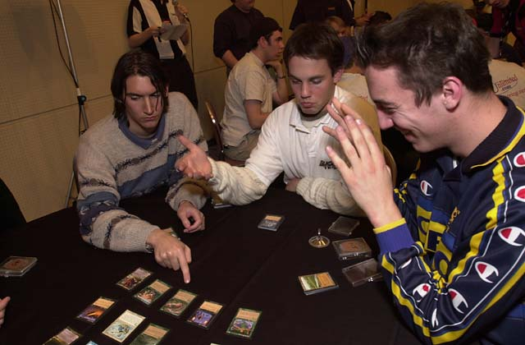
Black Ops drafts at Tokyo Masters
The big question concerning Team Rochester has to be what it is that has the pros singing its praises. Aside from the obvious fun aspect of having a team and friends to cheer on, the strategies involved go a little deeper than even individual Rochester. Drafting a deck for yourself is easy by comparison when you consider all of the additional elements involved in protecting your teammates and keeping an eye on those cards drafted by your opponent.
Briefly, Team Rochester sees two teams of three players sit with all the members of one team sitting side by side. The three players on either side are labeled A, B and C, their label corresponding with their seating arrangement, with A on the right, C on the left and B in the middle. After randomly deciding which team opens the first pack, the B player for that team does so, with the drafting of any given pack making its way clockwise around the table until the sixth drafter of that given pack selects two cards, sending the draft order back in the opposite direction. This rebounding pattern is repeated until all of the cards in the pack have been drafted. The next five packs are drafted the same way, with the opener of any given pack sitting to the left of the opener of the previous pack until all six players have opened packs, at which point the process is repeated in a counterclockwise fashion before repeating it a third time, once again going clockwise.
Phew.
Okay, now that I've overcomplicated things, what you're really doing is drafting a 1 on 1 Rochester, where instead of one deck, you draft three. What this means is that you have three decks to draft, and therefore three picks at a time. You have three opposing decks around which you have to draft your own, meaning three decks whose contents you need to remember so that you're ready for the tricks and color hosers that await you. In other words, while you usually are drafting one deck against the world, in this format, you're drafting 1 on 1, and its up to you to figure out how best to beat just one person: the one staring at you from across the table.

The Kick

A team can base many of their decisions on what the kicking team has betrayed about their draft strategy.
The first decision one needs to make is whether (assuming you win your coin flip) you'd rather 'kick,' meaning that your team's B player opens the first pack, or 'receive' meaning your opponent's B player opens the first pack. Throughout PT New York, Potato Nation (the team that I formed with Mike Turian and Scott Johns) chose to kick off. This wasn't as it may appear, because we wanted to establish colors first, but rather because we preferred more time to react to our opponent's colors. See, in each Rochester, 18 packs of 15 cards are opened, meaning each player gets 45 cards. Rather than just apply each of those 45 cards to drafting the best deck immediately available, one must understand that only 22-23 of those cards will actually make it into one's deck, meaning that the other 22-23 cards will be allocated to hate drafting, bad cards and keeping your options open. By choosing to go first, we understood that we might end up wasting a few early picks, but really, by the time the bulk of our early choices came around, we had an opportunity to see what our opponents were drafting, meaning that we could adjust without losing too much.
The opposite argument taken is that by choosing to receive; a team can base many of their decisions on what the kicking team has betrayed about their draft strategy. While this will often hold true, some kicking teams will allow the receiving team to make these adjustments only to make adjustments of their own, meaning that the receiving team is in essence kicking off. This is what Potato Nation tried to do.

Initial Color Selection
Now obviously, you can only pre-choose your colors as a loose idea of what you hope to do with each of your decks, with the eventual reality of the cards you open interfering with your best laid plans, but that doesn't mean that it isn't good to go into a draft with a preformed notion of how you want each deck to look when the draft is done.
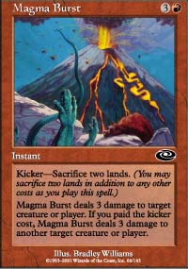
There are two ways to pre-select the colors you hope to have in each deck. The first is a look at the sets you'll be drafting and play their strengths and weaknesses. For example, right now, with the two packs of Invasion going either way canceling each other out, Planeshift is the set that should decide (using this method) how a team should draft their decks. As Planeshift consists of relatively weak Green and very strong Red, using this method, one might decide that a team should have two red players (preferably in seats A and C), with seat C also drafting black so as to give that deck as many shots at opening a Terminate, Magma Burst or Flametongue Kavu as possible. By default then, seat A would go GR (and usually white) while seat B would be left the blue.
Fortunately, Team Rochester isn't as simple as that. The second way of predetermining colors is to metagame around what you think your opponents will be drafting. If, for example, you think your opposition will be using the above method, then you'll want to draft a WG deck in the C seat, with large green creatures and Acolytes combating the RB kill spells better than most. At the same time, you'll want blue's bounce spells in seat A, protecting you from the aggressive WGR deck's creature enchantments and creature boosting tricks like Explosive Growth.
With Invasion Block, both of these methods are altered by the incredibly diverse mana base afforded and forced upon teams by green mana diversity spells like Fertile Ground and Harrow and gold cards. Not wanting to deprive your team of its most powerful options, Invasion Green gives a team the option of cutting off any powerful card regardless of color. As a result, in Tokyo, Potato Nation decided it would be best to draft two base-green decks in seats A and C and a base blue deck in seat B. This would stop all three decks from clashing with their next-door neighbors, all the while allowing two of our decks to act as the last defense against our opponents getting the most powerful cards in any given pack, at the same time stopping those powerful picks from going to waste in the sideboard. While we didn't win our one match, our draft went well enough that we very well could have, so don't let our 0-1 record fool you into thinking this wasn't necessarily the right plan of action.

Color Hosers

Being able to adjust to your opponent's deck is one of the most important aspects of the format.
One of the biggest differences between singles and team Rochester is the importance of knowing how strong any particular card will be against the one deck you're drafting against. As an example, Samite Archer is obviously a strong card, but knowing how many 1-toughness creatures your opponent has will often determine whether you'll want to pick it or, say, a Faerie Squadron for your one match up.
Among those cards whose value will greatly increase or decrease are color hosers. Cards that one might run main-deck in a singles draft, like an Acolyte, will either gain in value thanks to an opponent's commitment to the color that Acolyte is good against, or conversely be reduced to nothing by an opponent not playing that color. One of the skills required in this format is the ability to deduce when these cards are, or are not valuable in your individual match ups.
In Invasion Block, the most important of these cards may be Slingshot Goblin. With so many teams leaving blue in the middle seat by default, the Goblin, which is usually slightly better than a Grey Ogre, becomes the equivalent of a Master, gunning down opposing creatures for one mana per turn. Being able to adjust to your opponent's deck by picking cards like this one, Pygmy Kavu and the like earlier than you would in singles Rochester is one of the most important aspects of the format.

The Other Stuff
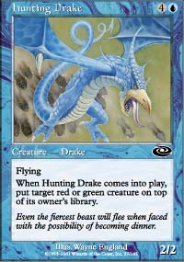
Keeping all the above in mind, you still need to make sure you've drafted a deck that is capable of competing. Concepts like mana curve and a creature count around 25 remain important, with the other concepts discussed here only adding to the stresses of the format. Don't make the mistake of thinking that a couple of Hunting Drakes against the GR deck will mean automatic victory: if your deck hasn't been properly constructed, all the metagaming and color hosing in the world won't help you win your match.
Aside from the additional strategic points, Team Rochester is held in the high esteem it is due to the fact that a mana screw can be nullified by one's teammates winning both their matches, and the fact that the individual becomes a part of something bigger, a fact that should be considered when choosing your teammates. Make sure that the people you play with are people you'll want to hang out with, while being able to trust their individual styles of play.
That's about it for this week. As always, if you have any questions or comments regarding the content of this column, feel free to email me at jgarywise@yahoo.com, and thanks to those who mailed me following last week's column. For those of you waiting on replies, sorry I've been taking so long as of late, but the mail's been piling up, so I'll get to it when I can. Have a good week.

